

REPUBLIC OF CAMEROON REPUBLIQUE DE CAMEROUN

PEACE - WORK - FATHERLAND PAIX - TRAVAUX - PATRIX

**INTERNET PROGRAMMING AND MOBILE PROGRAMMING TASK 4**

**PROJECT TEAM**

| **LEWIS TEM BUEH** | **FE20A057** |
| --- | --- |
| **MOFAKO BELTUS** | **FE20A065** |
| **MUKOH PRINCEWILL AJECK** | **FE20A068** |
| **EYAAN ZEEYAN ANTHONY JONATHAN** | **FE19A033** |
| **NGULEFAC FOLEFAC FOBELLA** | **FE19A081** |

**UML DIAGRAMS OF A MARKET MANAGEMENT SYSTEM**

Uml diagrams can be useful in designing because it helps us to visualize a system before diving deep into it’s design architecture. Here below are the uml diagrams for the market management system

* **USE CASE DIAGRAM**

Here we see we have 3 main actors in the system and also see how these actors interact or affect the system

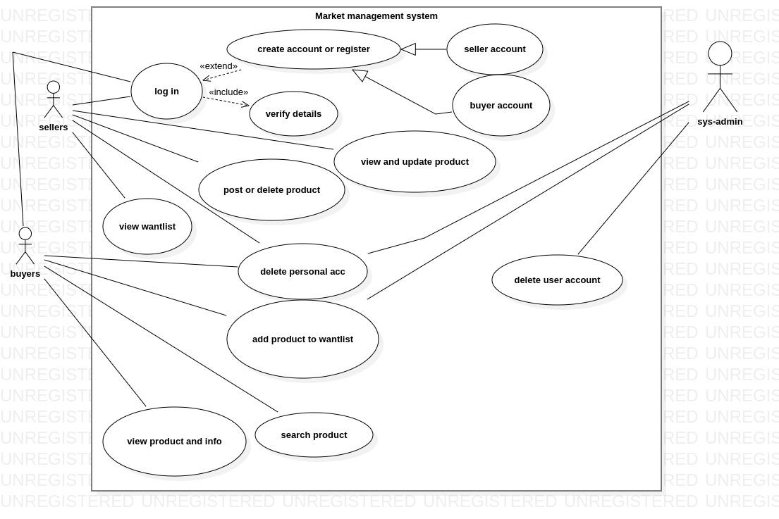

* **CLASS DIAGRAM**

This diagram can be derived from the usecase diagram, it shows the classes(actors) their attributes

or properties, and the different functions they can use(methods) on the system. It also shows the

relationship between the classes.

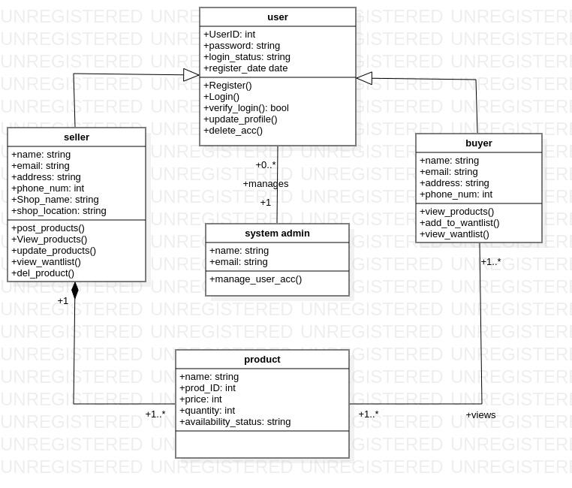

* **ACTIVITY DIAGRAM**

Describes how the activities performed on the system in flowchart manner

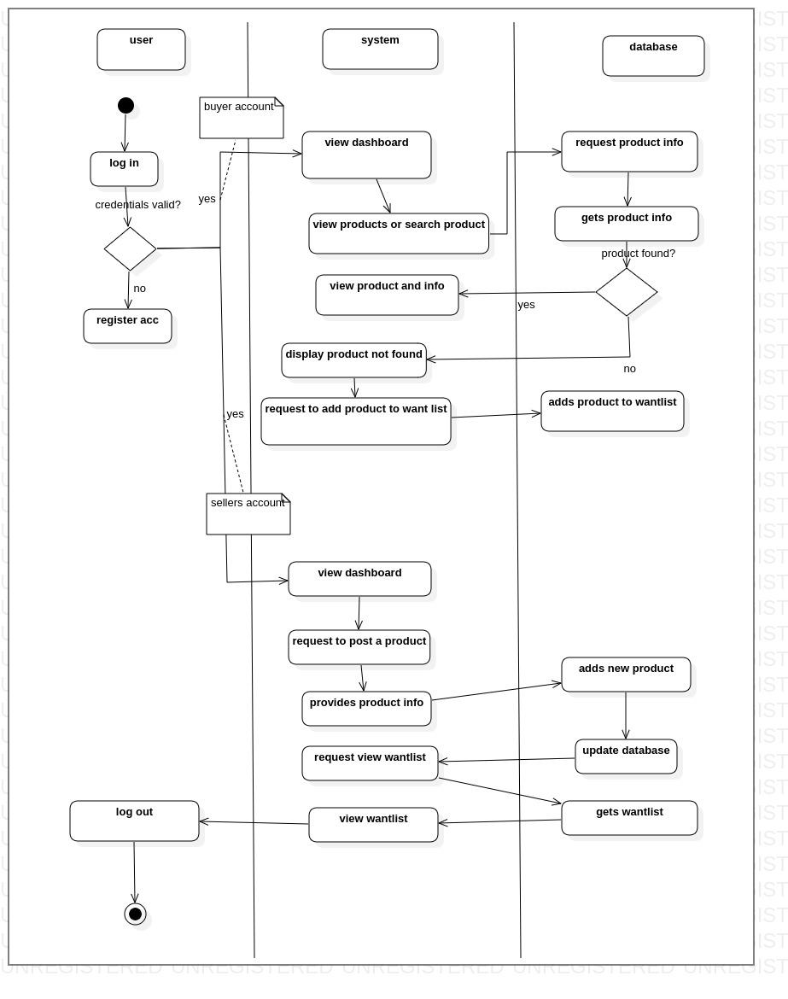

* **SEQUENCE DIAGRAM.**

Here we will look at the various sequence diagram from the various use cases

1. **SEQUENCE DIAGRAM FOR LOGIN AND REGISTRATION**

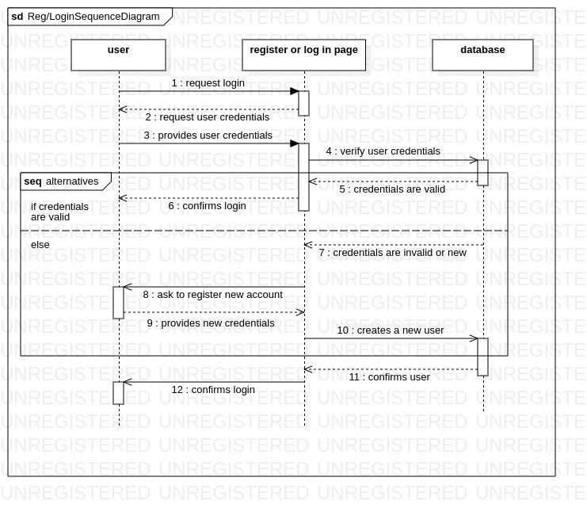

1. **SEQUENCE DIAGRAM FOR DELETION AND POSTING OF PRODUCT**

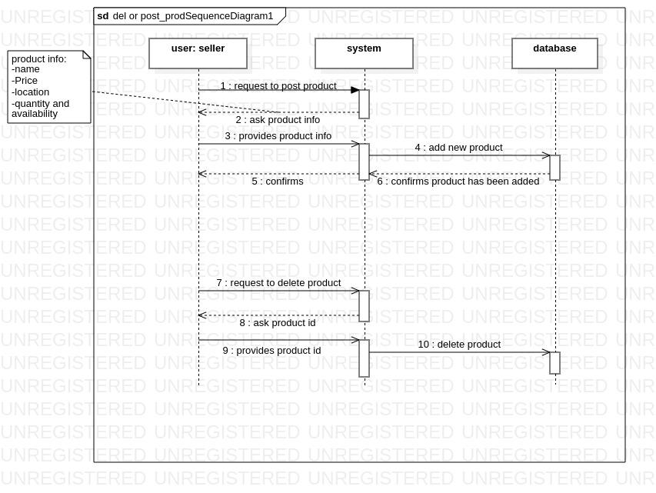

1. **SEQUENCE DIAGRAM FOR VIEW AND SEARCH PRODUCT**

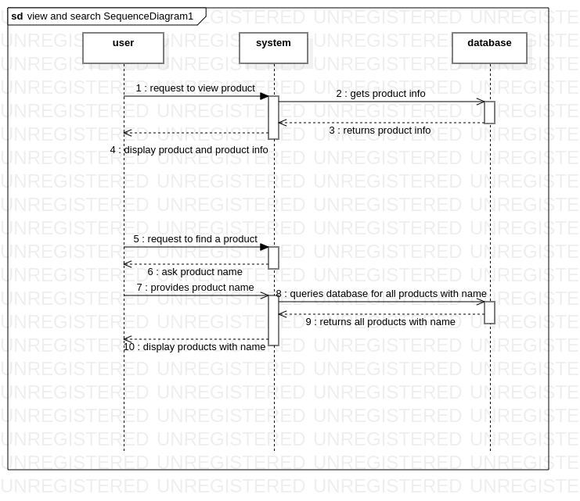

1. **SEQUENCE DIAGRAM FOR ADDING TO OR VIEWING FROM WANTLIST**

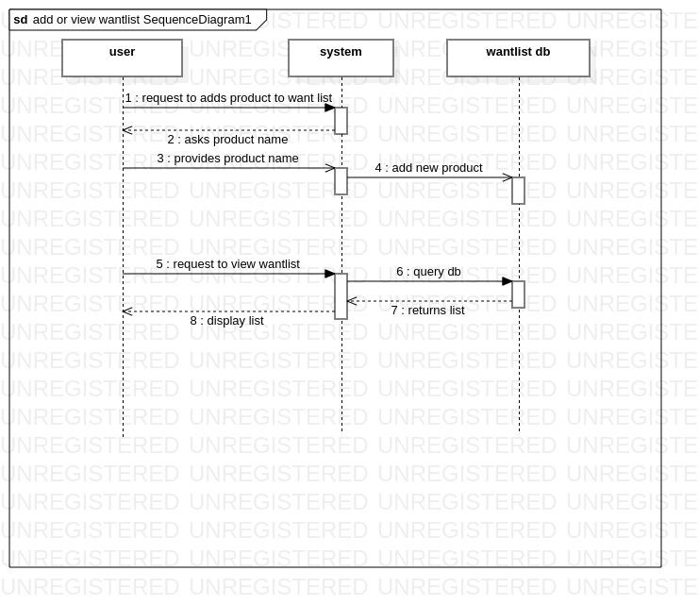

1. **SEQUENCE DIAGRAM FOR DELETION OF USER ACCOUNT**

